Assignment 5: Practical Application of DB-SCAN and A* Algorithm

Q1. DB-SCAN
Step 1: Visualize Data Before Clustering
- Using the provided code and plotting the graph
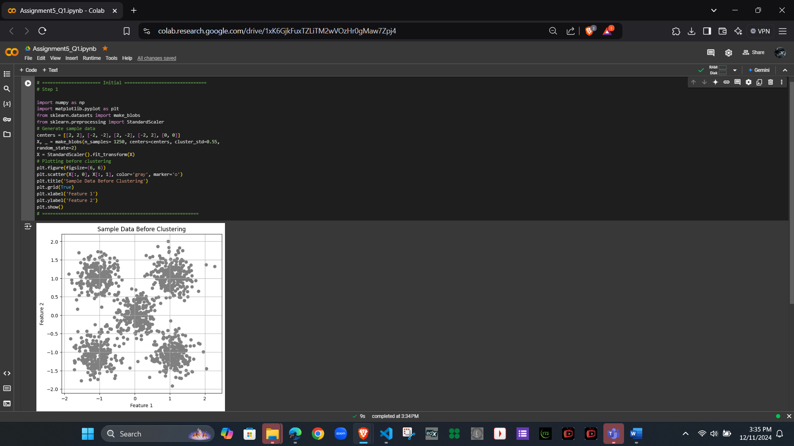

Step 2: Implement K-means Clustering and Determine Optimal Clusters
- K-means and elbow method code
- Plotting the elbow method graph
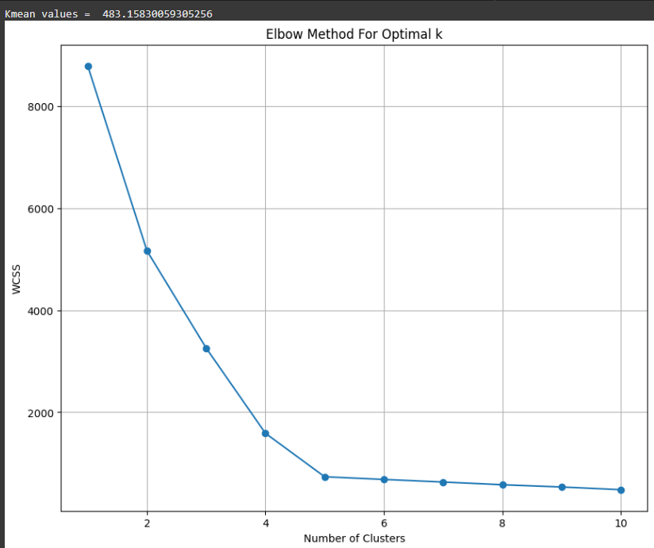
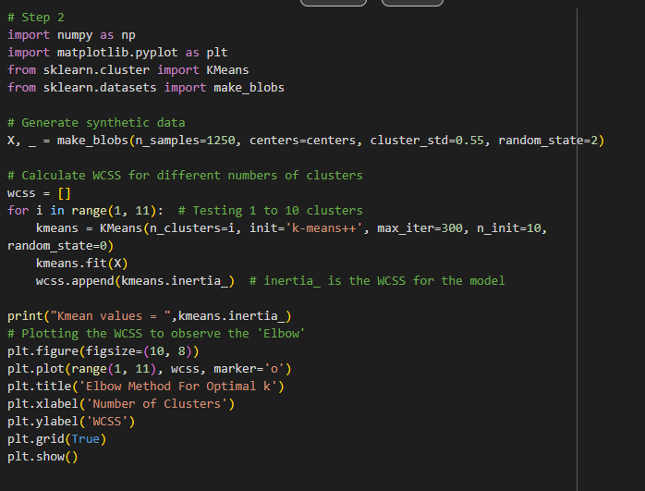
Kmean values = 483.15830059305256

Step 3: Visualize Data After Clustering
- Found by best K-means with K values from step 2
- Plotting the graph
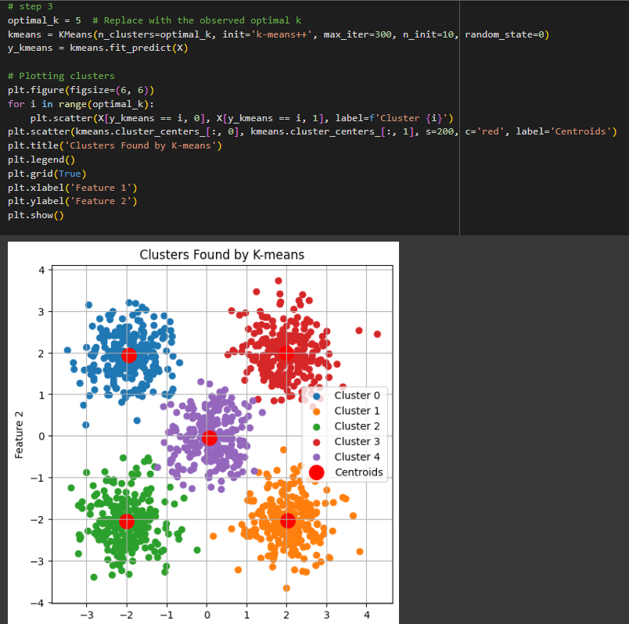

Step 4: Applied data from step1 with DB-SCAN
- Using the DB-SCAN algorithm to identify clusters
- Set epsilon parameters to 0.19
- Min_samples to 9
- Plotting the graph
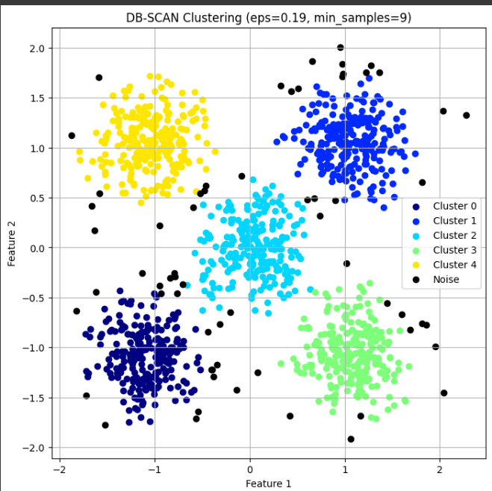
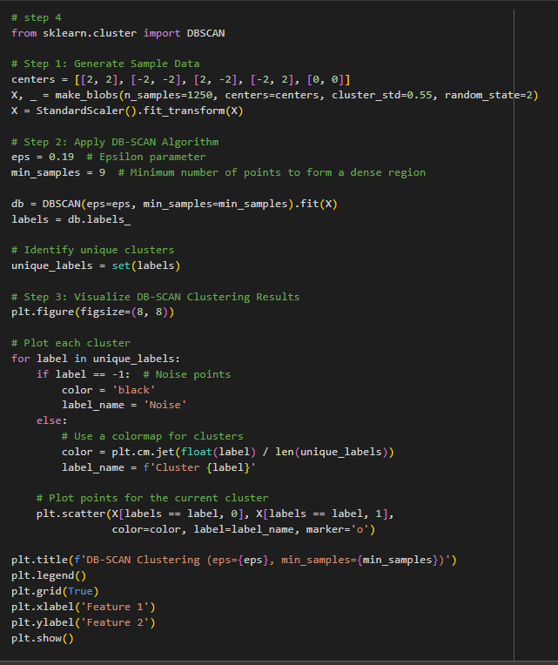

Step 5: Interpreting Results
Interpretation of Results: K-means vs. DB-SCAN
- K-means Clustering:
  - Output: K-means groups the data into a predefined number of clusters (k). It assigns every data point to the nearest cluster center.
  - Visualization: You can observe well-separated clusters if the data is spherical and evenly distributed.
  - Key Observations:
    - K-means successfully clustered the dataset into distinct groups when the clusters were clearly separated.
    - It assigned all points to clusters, meaning no noise was detected.
    - The elbow method was helpful in determining the optimal number of clusters.
- DB-SCAN Clustering:
  - Output: DB-SCAN forms clusters based on density and marks points that don't belong to any cluster as noise (-1).
  - Visualization: DB-SCAN effectively separated clusters and identified outliers or noise points in the dataset.
  - Key Observations:
    - DB-SCAN handled non-spherical clusters well and separated clusters based on density rather than distance from the center.
    - It detected noise in areas where the density was too low to form a cluster.

Pros and Cons of Each Algorithm:
- K-means Clustering:
  - Pros:
    - Fast and computationally efficient for large datasets.
    - Works well for spherical, well-separated clusters.
    - Easy to understand and implement.
  - Cons:
    - Requires predefining the number of clusters (k).
    - Sensitive to initialization of centroids and outliers.
    - Poor performance on datasets with non-spherical or overlapping clusters.
- DB-SCAN Clustering:
  - Pros:
    - Can detect clusters of arbitrary shapes.
    - Identifies noise and handles outliers effectively.
    - Does not require the number of clusters to be predefined.
  - Cons:
    - Sensitive to the choice of eps and min_samples parameters.
    - Struggles with datasets that have varying densities.
    - Computationally expensive for large datasets.

Additional code:
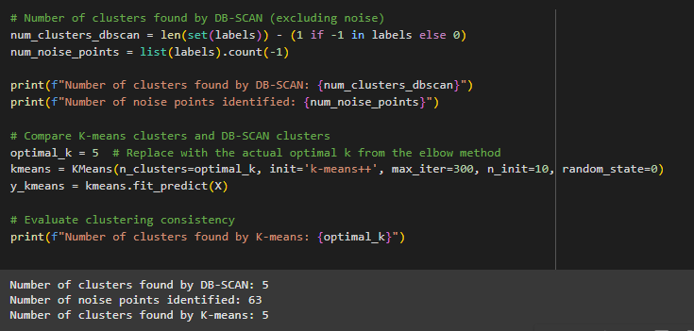
Number of clusters found by DB-SCAN: 5
Number of noise points identified: 63
Number of clusters found by K-means: 5

Q2. A* algorithms
Step 1: Task Setup
- Find the shortest path to the goal state.

Solution found in 2 moves with total cost = 2

Step 2: Testing
- Testing the A* algorithm with alternative start points, such as: ((2, 5, 4), (0, 8, 3), (1, 7, 6)).

Solution found in 13 moves with total cost 13

